**DIVE SITES DATABASE User's Guide**

**Record Attributes**

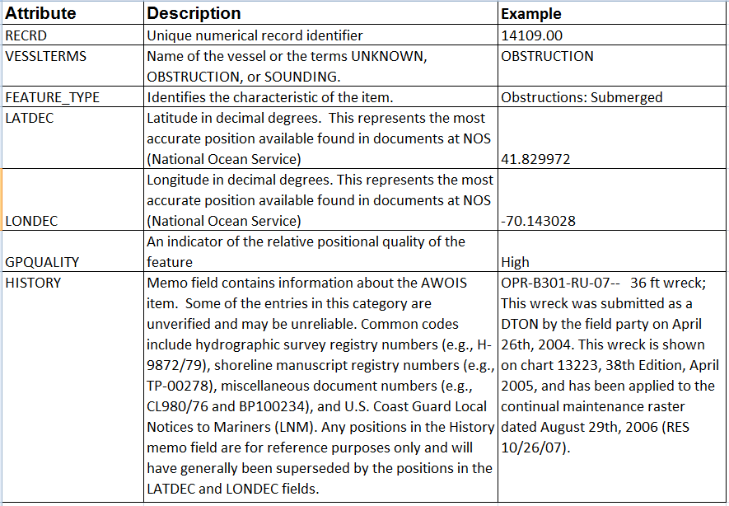

**GP QUALITY ID CODES**

